Connecting the dots: Christian values and climate action
This one-hour activity helps people of all ages understand their connection to climate change.
Time: 1 hour
Materials: Paper, pens and/or markers
Room set-up: chairs organized in a circle
Outline:
Time | Topic | Instructions
5 mins | Intro | Outline what you will cover today.
5 mins | A place you love | - Have participants draw or describe with words a place that they love. It could be anywhere they like to spend time—e.g. their back yard, city, nation, favorite park, etc.  - While they are drawing, ask them to think about why they love this place.
5 mins | Christian Values | - Have participants discuss with their neighbor: what do you value, as Christians, that you can agree on? How do these values inform how you live in the place you love?  - Have pairs write 2 or 3 of these values on their drawings.  - In the large group, have pairs shout out the values they wrote down
10 mins | Understand the impacts of climate change | - As a group, brainstorm some of the impacts of climate change (see below for some ideas).  - Direct the conversation to address both impacts abroad, and in Canada  - Have participants consider: will climate change impact the place that you love?  - If so, draw this on your picture!  - If not, where will climate change have the most impacts? Who loves and lives in these places?
10 mins | Understand the causes of climate change | - As a group, brainstorm some of the impacts of climate change (see below for some ideas).  - Have participants consider: do you do things in the place that you love that cause climate change?  - If so, draw them on your picture!  - If not, what/who is causing climate change?  - Have participants notice those who cause climate change don’t always inhabit the places that are most impacted—this is why it’s easy to ignore responsibility for climate change!
5 mins | Back to values | - Have pairs discuss: how do our Christian values inform how we respond to these causes and impacts of climate change?
20 mins | Take responsibility for the solutions to climate change | - As a group, brainstorm what is needed to address climate change (see below for some notes to get you started).  - Have pairs discuss: what concrete actions can be taken by your church? Your workplace? Your family? By you?  - Time permitting, have participants share their ideas with the group
5 mins | Commit to action | - Have participants consider: what will you do to take responsibility for the solutions to climate change?  - Have participants draw or describe themselves doing this action in their place.

A CONCRETE ACTION FOR TODAY:
PARTICIPATE IN FEDERAL CLIMATE CONSULTATIONS: Environment and Climate Change Minister, Catherine McKenna, has announced public climate consultations. Submissions are requested before June 1, but will be collected throughout the summer.
Share your stories and recommendations for climate action either in-person at a climate change town hall, or online using CPJ’s consultation template at cpj.ca/climate-consultation.

Background information for the facilitator:
We encourage you to use these notes to prepare for your workshop, not to present to participants. Keep the focus of the workshop on engaging personal connections to, and responsibility for, climate change—not the presentation of facts.

Impacts of Climate Change:
- OVERVIEW: Climate Change hurts people and the planet -- and Canada
  - Climate change is already negatively impacting physical, biological, and human systems around the world.
  - The two main consequences of climate change are ocean acidification and increased average global surface temperatures.
  - Ocean acidification, caused by the increased uptake of CO₂ by oceans, is negatively affecting marine ecosystems and fisheries.
  - Increased temperatures are changing precipitation and snowmelt patterns, impacting the quantity and quality of water resources for human consumption and ecological life-support. Higher temperatures are also increasing the risk of both flooding and drought. Permafrost temperatures are increasing, glaciers and sea-ice sheets are shrinking, global sea levels are rising, and the frequency of heat waves is increasing.
  - With further warming, the IPCC projects increased risk to coastal systems and low-lying areas, marine systems, food security and production systems, urban and rural inhabitants (particularly the poor), economic sectors and services, and human security.
  - This is particularly concerning, because those who will feel the greatest impacts of climate change live in areas with lower per capita income and higher predicted initial temperature increases.
- on weather: more frequent, longer, intense Extreme weather
  - Heavy precipitation
  - Flooding
  - Heat waves
  - Droughts
  - High winds and storms
- on oceans
  - Increased coastal erosion
  - Increased coastal flooding
- on water quantity and quality:
  - Less water in lakes
  - Decreased summer stream flow
  - Decreased soil and surface water
- on urban areas, which are especially vulnerable to:
  - Smog (ground level ozone)
  - High winds and storms
  - Water quality and quantity issues
  - Intense precipitation and flooding
  - Extreme heat
    - Toronto will have 50+ days greater than 32°C by 2080, and 2x heaty mortality rates by 2050.
- on agriculture:
  - Change in distribution and abundance of pests (e.g. Asian soybean rust)
  - Increased plant and tree stress make them more susceptible to disease and pests
  - Growing season longer and warmer, but very limited by decreased water
  - Heat stress impacts animal health and fertility
  - Flooding increases illness in animals
- on health:
  - Increased smog
  - Increased heat waves
  - Increased infectious disease (malaria, dengue, yellow fever in North America)
  - Decreased quality of drinking water
- on natural resources:
  - Increase wildfire (2x the area burned by 2100)
  - Decreased quantity and quality of wood for logging
  - Risk of structural damage to mining retention walls (e.g. in N. Ontario) that rely on frozen ground
- on transportation:
  - decreased ice road accessibility (especially critical for Northern First Nations communities!)
  - increased road infrastructure maintenance

Causes of Climate Change:
- What is climate change?
  - "Climate change" occurs when long-term weather patterns are modified. The popular usage of this term refers to the human-induced increase of atmospheric greenhouse gas concentrations beyond natural levels.
  - Greenhouse gases (GHGs)--like carbon dioxide and methane--in the atmosphere absorb some of the solar energy entering and exiting Earth’s atmosphere. These gases then transfer this energy to the other gases, effectively heating up the atmosphere. GHGs are good, to an extent. They exist naturally to help keep the Earth warm enough to support life.
  - Recently, however, concentrations of GHGs in the atmosphere have surpassed the levels of natural variability that can be assimilated by Earth systems. This higher quantity of atmospheric GHGs is a problem because it is heating up the Earth and acidifying the ocean.
- Human activity is causing climate change
  - 78% of the increase in greenhouse gas emissions observed between 1970 and 2010 can be attributed to increased combustion of fossil fuels and industrial processes driven by economic and population growth.
  - Earth’s average surface temperature has increased by over 0.85°C since the industrial revolution. This is concerning because although earth’s climate has always fluctuated, the rate of climate change has increased dramatically due to human activity as societies have industrialized.
- The global carbon budget is limited
  - Carbon dioxide is the major greenhouse gas released by humans, accounting for about 75% of human emissions (followed by methane and nitrous oxide). Cumulative (i.e. total since the industrial revolution) emissions of CO₂ largely determine how much the earth has warmed and will continue to warm.
  - If humans emit more than 2900 Gigatonnes (Gt) (i.e. billion tonnes) of Carbon Dioxide, we will almost certainly exceed a 2°C increase in global average surface temperatures (compared to the period 1861-1880). In order to have a greater than 66% probability of limiting this warming to 1.5°C, humans can only emit a total of 2250 Gt.
  - Since 1870, humans have emitted around 1999 Gt of CO₂. This leaves us with around 900 Gt to emit within a 2°C budget or 250 Gt within a 1.5°C budget. If we were to continue emitting at our current rate (a conservative average of around 36 Gt per year since 2005), we would use up these budgets in less than 25 and 7 years, respectively.
  - Climate models that result in a likely chance of keeping temperatures below 2°C require substantial action before 2030, with global emissions reductions of 40-70% below 2010 in 2050, and 100% or more by 2100. Based on current pledges made for the Paris Agreement, and without enhanced ambition, the likely global average temperature increase will be between 3-3.5°C by 2100.
- Canadians contribute to climate change
  - Canadian greenhouse gas emissions (CO₂, CH₄, N₂O, and synthetic) had a warming effect equivalent to 732 Million tonnes of CO₂ (MtCO₂eq) in 2014.78% (574 Mt) of these emissions were CO₂.
  - Canadian emissions by economic sector: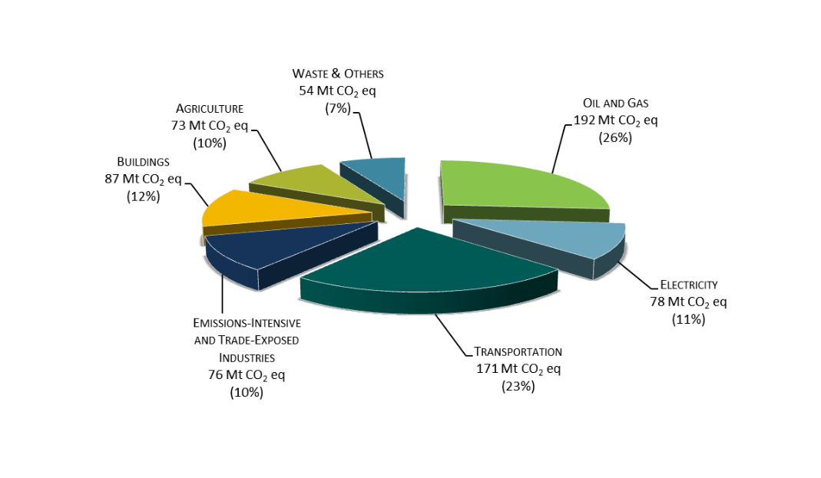
  - This represents about 1.6% of global emissions, and works out to per capita emissions of about 16.1 tonnes CO₂ compared to the global average of 4.9 tCO₂ per person.
  - With current measures to address climate change, Environment Canada has projected that Canadian emissions will grow to 768Mt CO₂eq in 2020 and 815 Mt CO₂ eq in 2030 – i.e. 3% greater than 2005 levels in 2020 and 9% greater than 2005 levels in 2030.
- Government intervention is needed
  - We can each make an important contribution to the Canadian emissions reduction effort, however individual actions are not enough to achieve Canadian targets and limit global warming below 2°C.
  - To achieve Canada’s current emissions reduction target (30% below 2005 by 2030) via personal emissions reduction efforts, on average, every Canadian would need to reduce their annual emissions by 7.9 tonnes.
  - To put this in perspective, we emit one tonne of emissions when we drive the average Canadian vehicle 4100km. On average, each Canadian vehicle emits 4.6 tonnes of greenhouse gases each year. So even if we stopped driving completely, we would still fall short of the personal reductions needed to meet Canadian targets.
  - Even though Canadian per capita emissions have declined by almost 2 tonnes since 1990, national emissions have increased by 119 Mt CO₂eq. This increase has largely been driven by mining and upstream oil and gas production, and transport.

Solutions to Climate Change: 3 steps you, and your church, can take towards climate justice
- ACKNOWLEDGE: Learn about and meditate on the need for climate justice
Meaningful action on climate change grows from understanding its causes, accepting personal responsibility for our contributions, and seeking awareness of its negative impacts on those who are most vulnerable to its impacts.
  - Use CPJ's faithful climate action worship resources for churches to incorporate climate justice themes into prayer and worship, or start a conversation in your church.
  - Find out what your national church has said and done on climate change.
  - Reflect, pray, and take action with CPJ’s book, Living Ecological Justice: A Biblical Response to the Environmental Crisis. It’s designed for a small group study or church-wide use. You can also draw on our Living Ecological Justice additional reading and video pages.
  - Join “Fast for the Climate,” the world-wide movement with CPJ staff and members, as well as other organizations and individuals who are fasting and engaging in environmental advocacy on the first day of every month.
  - Invite CPJ to speak to your organization or facilitate a workshop on faith and ecological justice. Contact Karri Munn-Venn for more information.
- ACT: Reduce your environmental impact
  - Use and promote online tools that help people understand their environmental impact and ways they can reduce it individually and corporately. Greening Sacred Spaces and Carbon Footprint offer a carbon footprint calculator.
  - Divest from carbon-based assets and invest in clean technology. Read “Divest and Reinvest Now! The Religious Imperative for Fossil Fuel Divestment and Reinvestment in a Clean Energy Future,” by the Rev. Fletcher Harper of GreenFaith. Engage your faith community in a discussion about divestment using background papers and discussion guides available at Fossil Free Faith.
  - Conduct a Green Audit, and improve the energy efficiency of your faith community's infrastructure. Greening Sacred Spaces offers Green Audits as a fee for service, and on their website you'll find resources on improving the energy-efficiency of religious buildings, organizing a church "Green Team" to facilitate greening, and a "Green Guide" with other suggestions on "how to live your faith and walk more lightly on the planet."
- ADVOCATE: Engage with Canadian Political Leaders
Living out the call to care for the environment requires both individual-level and legislative-level changes. While personal greening initiatives do slow environmental degradation and enhance the way we see our relationship with creation, they are inadequate if we don’t also work for societal and public policy reform.
  - Read and share the ecumenical statement, “On Promoting Climate Justice and Ending Poverty in Canada." This call for federal action on climate change and poverty was coordinated by the Canadian Council of Churches in September 2015 and endorsed by more than 65 signatories (including CPJ, Canadian Christian, Sikh, and Buddhist leaders).
  - Write an email or letter to, or meet with your MP to let them know that you are concerned about climate change. Urge them to support strong Canadian action towards climate justice (use information from "Understand the Issue" to provide your MP with up-to-date policy suggestions). You can use this sample letter [word doc] to get you started.

Citizens for Public Justice seeks human flourishing and the integrity of creation as our faithful response to God’s call for love and justice.
We envision a world in which individuals, communities, societal institutions, and governments all contribute to and benefit from the common good. Our mission is to promote public justice in Canada by shaping key public policy debates through research and analysis, publishing, and public dialogue. CPJ encourages citizens, leaders in society, and governments to support policies and practices which reflect God’s call for love, justice, and the flourishing of Creation. Learn more at cpj.ca.

See IPCC WG1 AR5 SPM for more details
The UN’s Intergovernmental Panel on Climate Change
IPCC WG1 AR5 SPM
IPCC WG1 AR5 SPM
IPCC AR5 Synthesis report Table 2.2
Global carbon Project, 2015 Global Carbon Budget
Average CO2 emissions between 2005-2014 (excludes contributions from other GHGs). The Global Carbon Project predicts that growth in global CO₂ emissions from fossil fuels and industry will be near zero in 2015, resulting in global emissions of 35.7 ± 1.8 GtCO₂ in 2015). 2015 Global Carbon Budget
Author's back-of-the-envelope calculations
IPCC WG1 AR5 SPM
UNEP 2015 Emissions GAP report
Canadian Environmental Sustainability Indicators: GHG emissions: ECCC (April 2016)
For more info, and graphs from the 1990-2014 National Inventory Report http://bit.ly/ECCC2016NIR
Most current data available from 2012. Canada’s 2016 NIR
(Of Carbon Dioxide Exclusively). Author calculation based on 20.6 tonnes of CO₂eq/capita when you include all GHGs. Canadian Environmental Sustainability Indicators: GHG emissions: ECCC (April 2016) and population estimate for July 1 2014 (CANSIM table 051-0001)
Global carbon budget project
Ecofiscal Commission and Environment Canada
Author calculation based on current Canadian per capita emissions of 20.6 tCO₂eq., assuming M1 (medium) population growth scenario for 2030 (Statistics Canada Publication 91-520-X).
Author calculations: burning 1 L of gasoline produces 2.3kg of CO₂ (NRC). The average Canadian car uses 10.6 L of gasoline to go 100km (NRC). I.e. 0.24 kg of CO₂ per kilometer travelled.
Canadian Environmental Sustainability Indicators: GHG emissions: ECCC (April 2016)
85Mt of these emissions are from increased production of crude oil and expansion of the oil sands (Environment Canada).

